$$Hierarchical cluster$$

$$It is also called as Aglomarative cluster$$

$$It is also called as bottom to top appraoch$$

$$It will assume each data point is one clsuter$$

$$Based on distances it will link the data points and form the cluster$$

$$at top level all the data points becomes one clsuter$$

$$starting we have n data points , so we have n clusters$$

$$at the end all the data points becomes a 1 cluster$$

$$The clsuters are varies from n to 1$$

$$These clsuters are formed based on linkage functions$$

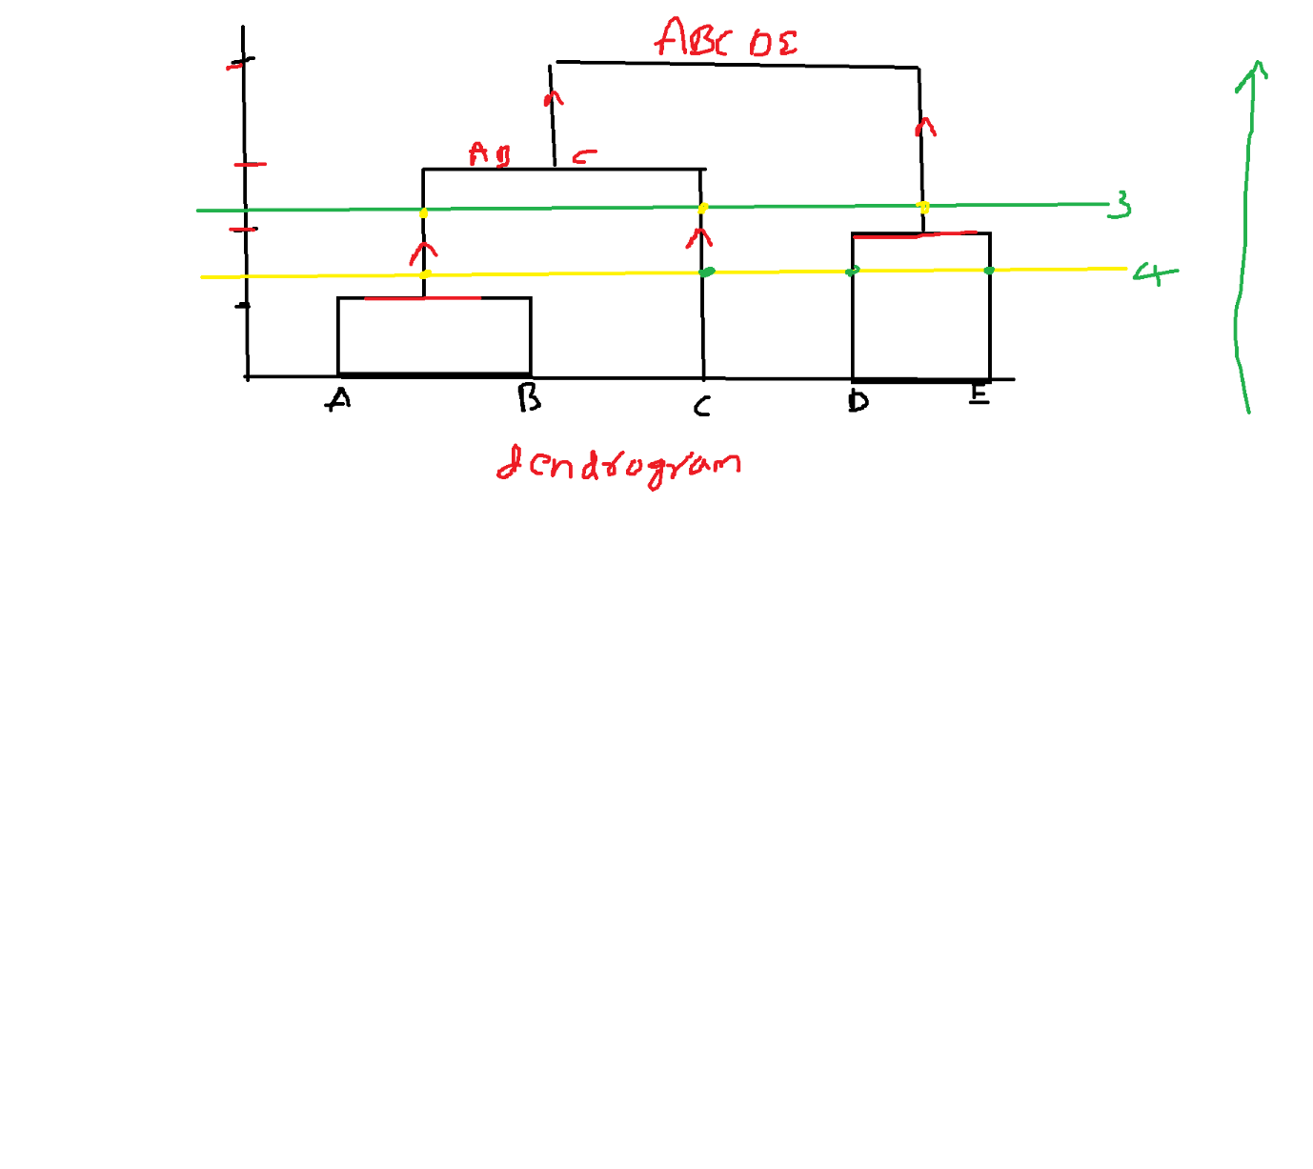

|  |  |  |  |  |  |
| --- | --- | --- | --- | --- | --- |
|  | A | B | C | D | E |
| A | ---- | 2 | 7 | 9 | 4 |
| B | 2 | ---- | 9 | 11 | 14 |
| C | 7 | 9 | ---- | 4 | 8 |
| D | 9 | 11 | 4 | --- | 2 |
| E | 4 | 14 | 8 | 2 | --- |

|  |  |  |  |  |
| --- | --- | --- | --- | --- |
|  | A | C | D | BE |
| A | ---- | 7 | 9 | 2 |
| C | 7 | --- | 4 | 8 |
| D | 9 | 4 | --- | 2 |
| BE | 2 | 8 | 2 | --- |

A to BE = ?

A to B: 2

A to E: 4

(2,4) how many ways pick

1. Max (2,4) : Single linkage : Max similarity or Min distance
2. Min(2,4) : Complete linkage : Min similarity or Max distance
3. Avg(2,4) : Average linkage

A to BE : 2

C to BE=?

C to B: 9

C to E: 8

(9,8) complete linkage= 8

C toBE=8

D to BE:

min(11,2): 2

|  |  |  |  |  |
| --- | --- | --- | --- | --- |
|  | A | C | D | BE |
| A | ---- | 7 | 9 | 2 |
| C | 7 | --- | 4 | 8 |
| D | 9 | 4 | --- | 2 |
| BE | 2 | 8 | 2 | --- |

Highest pair from above table : A-D:9

BE ,AD, C

|  |  |  |  |
| --- | --- | --- | --- |
|  | AD | BE | C |
| AD | ---- | 2 | 4 |
| BE | 2 | --- | 8 |
| C | 4 | 8 | -- |

AD -BE

BE we already have from above table

BE-D : 2

BE-A : 2

Complete linkage = min(2,2)= 2

AD-BE:2

AD-C

A-C:7

D-C:4

Min(7,4)=4

AD-C:4

|  |  |  |  |
| --- | --- | --- | --- |
|  | AD | BE | C |
| AD | ---- | 2 | 4 |
| BE | 2 | --- | 8 |
| C | 4 | 8 | -- |

Hpair= BE-C=8

AD and BEC

Case-1: BE

Case-2: AD

Case-3: BEC

Case-4: ADBEC